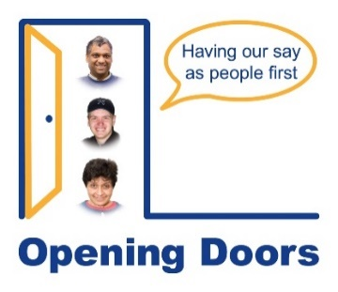
Opening Doors Job Application Form
Thank you for your interest in working with Opening Doors. We want our recruitment process to be fair and accessible.
You can complete this form by typing into it or by sending a video or audio recording instead (any recording would need to cover all the areas in this form).
About you
Name | Click or tap here to enter text.
Preferred name (if different) | Click or tap here to enter text.
Email address | Click or tap here to enter text.
Phone number | Click or tap here to enter text.
Town/city you live in | Click or tap here to enter text.
Support and adjustments
Do you need any support or adjustments to take part in an interview? |  | Choose an item.
If yes please tell us what would help |  | Click or tap here to enter text.

Why do you want to work for Opening Doors - Please tell us in your own way
Click or tap here to enter text.

Your experience - Tell us about any experience you have that is relevant to this role.
This can include paid work, volunteering, lived experience or community activities
Click or tap here to enter text.
Your education and training - Tell us about education at school, college, university or other training that you have done. Please start
Click or tap here to enter text.

Supporting people – tell us about a time you have supported someone (in any setting).
What did you do and what was important?
Click or tap here to enter text.
Working with people who have learning disabilities – this role involves working with people with learning disabilities. What do you think is important to do this well?
Click or tap here to enter text.

Teamwork – tell us about a time you worked as part of a team. What worked well? What did you do?
Click or tap here to enter text.
Values – Opening Doors is a user-led organisation. What does this mean to you?
Click or tap here to enter text.

References – please give details of two referees (not family members)
Referee 1
Name | Click or tap here to enter text.
Relationship to you | Click or tap here to enter text.
Organisation | Click or tap here to enter text.
Email/phone details | Click or tap here to enter text.
Referee 2
Name | Click or tap here to enter text.
Relationship to you | Click or tap here to enter text.
Organisation | Click or tap here to enter text.
Email/phone details | Click or tap here to enter text.

Criminal Convictions – this role requires a DBS check
Do you have any criminal convictions or relevant information you need to tell us about? | Choose an item.
If yes please give details. (We understand people may have past convictions. This will not automatically stop you getting the job).
Click or tap here to enter text.

Declaration – I confirm the information I have given is true
Name | Click or tap here to enter text.
Date | Click or tap here to enter text.

Please complete and email to admin@openingdoors.org.uk by 9.00am Tuesday 26 May 2026.

