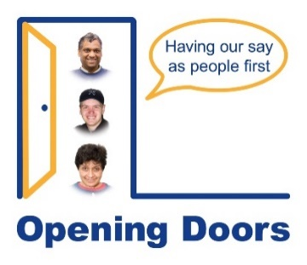
Opening Doors Equal Opportunities Monitoring Form
This form is for monitoring purposes only. It will not be seen by the shortlisting panel and will not affect your application.
You do not have to complete this form.
Disability
Do you consider yourself to be disabled? | Choose an item.

Ethnicity
What is your ethnic group? | Choose an item.
If you would like to tell us more please write here (optional): Click or tap here to enter text.

Gender
What is your gender? | Choose an item.
If you prefer to self describe please write here Click or tap here to enter text.

Age
What is your age group? | Choose an item.

Sexual Orientation
Please choose an option | Choose an item.

Caring Responsibilities
Do you have caring responsibilities? | Choose an item.

How did you hear about this role?
Please choose an option | Choose an item.
To fill in somewhere else you hear about this post please type here Click or tap here to enter text.

Please complete and email to admin@openingdoors.org.uk by 9.00am Tuesday 26 May 2026.

